Academic Year: 2025-26 | Year: Second Year | Semester: II
PRN No.: 1012411011 | Name: Riddhee Kulkarni
Subject: Python Programming
Assignment No.: 16
Date: 02/02/2026

Lab Assignment: 16
Aim:
Write a program to calculate GCD using recursive functions.

Objective:
To understand and implement recursion using Euclid’s algorithm.

Theory:
GCD (Greatest Common Divisor) is the largest number that divides two numbers exactly.
The GCD is calculated recursively until the remainder becomes zero.

Algorithm:
- Start
- Define a recursive function for GCD
- If second number is 0, return the first number
- Otherwise, call the function again
- Display the GCD
- Stop

Pseudo Code:
FUNCTION gcd(a, b)
IF b == 0
RETURN a
ELSE
RETURN gcd(b, a % b)
END IF
END FUNCTION

Code:
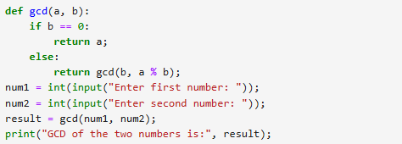

Output:
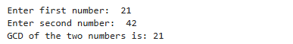

Conclusion:
The program successfully calculates the GCD of two numbers using recursion.

